**Digital Picture Frame User Guide**

# Digital PictureFrame User Guide

## 

## INTRODUCTION AND CAPABILITIES

### Overview

Digital PictureFrame enables you to view your digital photos, live photos (photos with a few seconds of video), and videos on a television screen or monitor. With it, you are in control of how and what gets displayed and have capabilities that other digital content viewers lack, such as:

* setting how long to display photos and videos
* temporarily hiding (or unhiding) photos you have marked as sensitive
* creating multiple playlists of photos and videos
* supporting a multilevel folder structure so that you can better organize your digital content and more easily customize playlists (many other applications/devices require a single level or folder of content)
* specifying how many photos and videos to show from each folder, which allows you to have the desired sample of items displayed before moving to another folder, such as 5 images from Croatia, 5 images from your child’s 5th birthday party, 5 images from the 2024 work holiday party, and so on
* ensuring that no digital item repeats until all are shown (in random order) from the active playlist, so that you have the opportunity to actually see all your desired content and not just the same items over and over again
* using any device’s browser, such as Safari on an iPhone, to control your digital content display and change settings

### Features & Functionality

Digital PictureFrame includes many capabilities, some of which are simply displayed on the monitor/television while it is running and others of which are functions accessed in one of two ways: through a Windows client application on your PC, or, through a web browser application on a mobile phone, tablet, or other device that supports web browsing.

The Windows application has the same configuration settings as the browser application, but it does not include commonly used functionality to control item display (Next, Previous, Pause, Volume, etc.). The web browser application provides access to all features, functions, and settings except for the Open Port setting, which is configured during installation and important not to accidentally change (so it is only accessible from the Windows application). Therefore while the Windows client application functions and settings are described briefly in the Installation & Initial Configuration section, the web browser application is the easiest way to interact with Digital PictureFrame and its capabilities are presented below.

#### Browser Home Screen

The following functions and capabilities are accessible from the browser application Home screen when Digital PictureFrame is running. These should be the most frequently used features.



**Figure 1. Home Screen (iPhone Example)**

| **Feature** | **Description, Directions and Notes** | |
| --- | --- | --- |
| Current Playlist | Provides access to a list of available playlists, with the currently active playlist selected (e.g., ‘allcontent’ is the current playlist as shown in the screenshot below):    **Figure 2. Current Playlist**   * Click on another playlist to select a different one to play. For example, you might have created a playlist for a family friend that you want to play whenever that friend visits. If you do not see a playlist you want and would like to create a new playlist, you can go to **Manage Playlists** from the More Optionsscreen to create it. * If you only have one playlist created, it will be the only option available in the list. * Click the **Save** button to save a change to the current playlist and return to the Home screen. * Click the **Cancel** button to discard a change and return to the Home screen. | |
| Delete - Mark | *Mark* the currently displayed and paused item for later manual deletion. Photos are not immediately deleted in order to safeguard against accidental deletion.   * The playlist must be paused before the displayed photo or video can be marked for deletion. If the **Delete - Mark** icon appears grey, select **Pause** to enable/un-grey it. * Once **Delete - Mark** has been selected:   + A confirmation image will be briefly displayed on the bottom right of the television/monitor () so that you know it has been marked for deletion.   + Note that pressing **Delete - Mark** again will *not* unmark for deletion (but again the item has not yet been deleted, just marked for deletion). * You can use the **Notifications** feature within the More Options Screen to view a list of all items currently marked for deletion. If you did not intend to mark the item for deletion, you can clear the deletion marking within Notifications (but note it will clear all other notifications too). * Be sure to select **Play** once you are done to unpause the playlist! | |
| Info - View | View the item’s associated comments (text description) and/or folder path of the currently displayed item.   * This information will appear on the bottom right of the monitor/television. * The ability to view comments only applies to .jpg photos and .mp4 videos. Unfortunately, .png and .gif files are not supported for storing comments. * If after selecting **Info - View** you only see the item’s folder path, there likely is no comment for the displayed item. You can use the **Info - Edit**feature within the More Options Screen to add or change comments. | |
| Magnify | Provides a magnification screen so that you can focus in on a circular region of the currently displayed item on the monitor/television.    **Figure 3. Magnification Screen**   * Press/click anywhere on the magnification screen and drag to move the magnification circle around on the currently displayed photo or video     **Figure 4. Displayed Photo with 2x Magnification Circle**   * Default magnification is 2x   + press the plus icon () to magnify to 4x   + press the minus icon () to decrease magnification back to 2x * Press the back arrow () when finished, to return to the Home screen and remove the magnification | |
| More Options | Provides access to additional options that are less frequently used, including:   * Current Folder Queue * Browser Application QR Code * Reset * Hide/Unhide (sensitive items) * Info - Edit * Configuration Settings * Manage Playlists (create, edit, delete) * Notifications (items marked for deletion and general warnings)   See the More Options screen for details. | |
| Next | Immediately progresses to display the next item in the queue. | |
| Pause | Pauses the current playlist.   * The currently displayed photo or video will remain in view until you explicitly select **Play** () * You can still use other features while paused, for example, clicking **Next** or **Previous** to automatically progress forwards or backwards in the playlist queue and which also keeps the pause state active * Note that pressing **Pause** while a video is displayed does not pause the playing of the video, it just pauses the playlist queue so that the video continues to play and loop until you explicitly decide to unpause/click **Play** or go to the next item * Use this feature to enable/ungrey the **Delete - Mark** and **Rotate** feature icons | |
| Play | Unpauses the playlist. It will revert to the **Pause** icon () once selected. | |
| Previous | Immediately regresses to display the item that was last displayed.  NOTE: If the prior photo or video was the last item in the preceding queue, clicking **Previous** will do nothing. When the currently displayed item is the first item in the current queue, there is no prior item in memory to go back to because the prior queue is no longer in memory. | |
| Rotate | Rotates the currently displayed .png, .jpg, or .mp4 item 90 degrees to the right/clockwise.   * The playlist must be paused before the displayed item can be rotated or marked for rotation. If the **Rotate** icon appears grey, select **Pause** to enable/un-grey it. * You can press **Rotate** multiple times until the desired orientation is reached. The next time the item is displayed, it will appear in the same desired orientation. * Be sure to select **Play** once you are done to unpause the playlist!   NOTE: Unfortunately, .gif files are not able to be rotated within the application and must be done manually. | |
| Volume | Provides a vertical volume bar so that you can increase or decrease, including muting, the volume level for videos:    **Figure 5. Volume Bar**   * Once the video volume bar appears, press/click and drag the volume icon upwards to increase volume (,,) or downwards to decrease volume, including completely muting (). * Simply press/click off the volume bar when you have reached the desired volume level and the control will disappear. * The volume level you set should persist for future videos. * Note that videos under a few seconds in length will have their volume automatically muted. This is to prevent live photos, which often have unappealing audio, from playing jarring and unexpected sounds. You can still increase the volume on a per live video basis if desired, but it will be independent from the persisted main volume setting. | |

#### More Options Screen

The following functions and capabilities are all accessible from the browser application More Options screen. These tend to be less frequently used features.

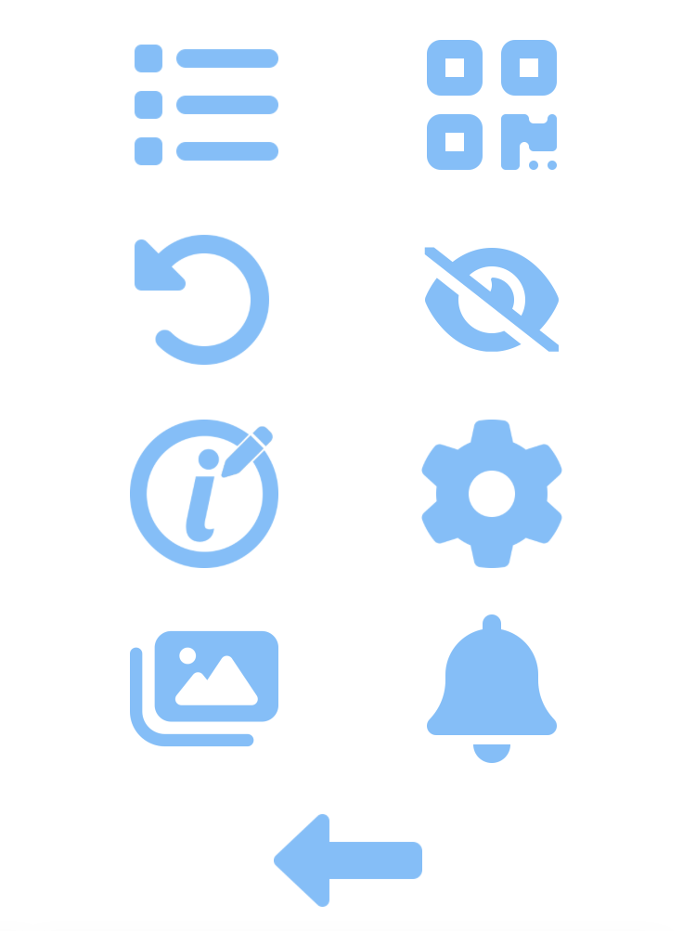

**Figure 6. More Options Screen (iPhone Example)**

| **Feature** | **Description, Directions and Notes** | |
| --- | --- | --- |
| Back to Home | Closes the More Options screen and returns you to the Home screen. | |
| Browser Application QR Code | Displays two IP addresses (one for version IPv6 and one for IPv4) and corresponding QR codes so that you can access the web browser application within another browser window. You can either:   * Enter one of the IP addresses in a browser window’s URL field along with the web browser application port, for example, ‘http://192.168.68.64:2149/’ from the screenshot below for Local IPv4 * Use a device’s camera on a QR code to identify and click on a link to open the application in the device’s default browser window * Select the **Back** arrow () to dismiss the view and return to the More Options screen.     **Figure 7. QR Code Display Screen (iPhone Example)** | |
| Configuration Settings | Provides access to settings that are very rarely changed, such as:   * Item Display Time * Items to Queue * Items per Folder to Queue * Top Item Folder * Pause loading new items between Start/End * Refresh playlists and item edits nightly * Refresh immediately via the ‘Save & Refresh’ button   See the Configuration Settings Screen for details. | |
| Current Folder Queue | Temporarily displays general information about Digital PictureFrame and its current playlist.  Within the upper left corner of the television/monitor:   * A list of all items in the current playlist queue, showing full file paths   Within the lower right corner of the television/monitor:   * Uptime (how long Digital PictureFrame has been running) in days, hours, minutes, and seconds * Total images identified for the current playlist * Used images, or those images that have already been displayed, for the current playlist | |
| Info - Edit | Temporarily pauses the playlist and opens the Item Info screen for the currently displayed item:    **Figure 8. Item Info Screen**   * This feature only applies to .jpg photos and .mp4 videos. Unfortunately, .png and .gif files are not supported. * Click within the **Comments** field to edit or add a text description or information about the displayed item. * Select the **Sensitive Item** checkbox if you would like to mark the item as hideable via the **Hide/Unhide** setting. * Deselect the **Sensitive Item** checkbox if you would like to mark the item so that it will always be displayable, no matter the state of the **Hide/Unhide** setting. * Select the **Save** button to save all changes, return you to the More Options screen, and automatically resume playing the playlist. * Select the **Cancel** button to *not* save any changes, return you to the More Options screen, and automatically resume playing the playlist.   NOTE: Saved changes to **Comments** and **Sensitive Item** will be saved immediately to the item file. However, you will not see these changes for the displayed item in Digital PictureFrame until it has had a nightly or manual refresh. See the Configuration Settings screen **Refresh playlists and item edits nightly**or **Save & Refresh** settings for more details. | |
| Hide/Unhide / | If you have one or more items marked as sensitive, selecting the Hide icon () will prevent those items from being displayed even if they are part of a playlist. You’ll know that sensitive items are actively being hidden whenever the Unhide icon () is visible. Selecting the Unhide icon will allow all sensitive items to be displayable in the playlist, and revert it to the Hide icon ().  Marking items as sensitive is useful if there is ever content you wouldn’t want a visitor to see. For example, perhaps you want to be able to hide photos of a visitor’s former boyfriends, or photos from a rowdy party a visitor would not approve of, and so forth. See **Info - Edit** for information on how to mark items as sensitive. | |
| Notifications | Displays the following notifications and information:    **Figure 9. Notifications**   * **Items Marked for Deletion** - List of photos and videos that have been marked for delete, including the file path so that you can find and manually move or delete the item. If no items have been marked for deletion, “*(no items)*” will appear in grey font. * **General Warnings** - List of minor issues and software commands that might have glitched at some point. These are primarily for use in technical support and debugging. If no warnings or errors have occurred, “*(no warnings)*” will appear in grey font.   Once you are finished viewing this information, you can either:   * Select the **Back** arrow () to *keep* all notifications and information intact and return to the More Options screen * Select the **Clear All** button to *remove* all notifications and information and return to the Home screen. For example, once you have manually deleted all desired item files, clearing these will prevent unnecessary reviews of these items in the future. | |
| Manage Playlists | Provides access to all currently available playlists so that you can:   * create a new playlist * edit an existing playlist * delete an existing playlist (via the Edit Playlist screen)   See the Manage Playlists screen for more details. | |
| Reset | Completely clears all information and restarts Digital PictureFrame, starting the current playlist from its beginning. | |

#### Manage Playlists Screen

The Manage Playlists screen shows all available playlists for editing, deleting, and creating new playlists. The currently active playlist is indicated with a blue star next to it. For example, ‘allcontent’ playlist in Figure 10 is the current playlist. Note that at least one playlist must always exist and that the currently active playlist cannot be deleted.

It is highly recommended that you read Playlists: Tips for Organizing and Naming Folders before creating playlists as it explains how playlists, playlist folders, and keyword searches work in detail and might make playlist creation more enjoyable and efficient.

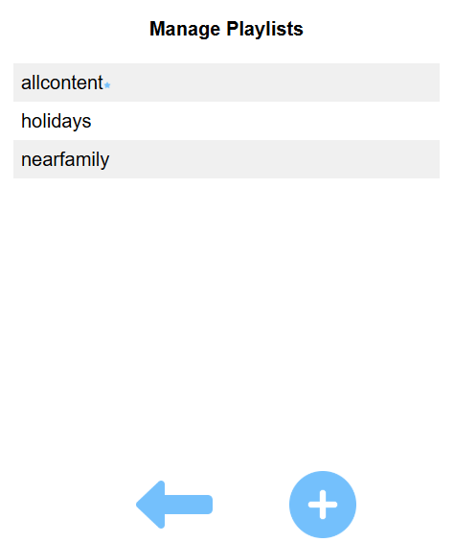

**Figure 10. Manage Playlists (iPhone Example)**

| **Feature** | **Description, Directions and Notes** | |
| --- | --- | --- |
| Back | Closes the Manage Playlists screen and returns you to the More Options screen. | |
| Create Playlist | Click the plus icon to open the Create Playlist screen:    **Figure 11. Create Playlist Screen**   1. Click into the **Playlist Name** field and enter a name.    * The name must be unique; it cannot already be in use by another playlist.    * The name cannot contain spaces, dashes, or other special characters. If these are entered, the application will remove them. 2. When creating a playlist you must select one or more specific folders to include so that the playlist will know where to retrieve photos and videos. All of the digital content from that folder and all its subfolders will be included in the playlist unless you filter further by providing keywords. These specific folders are identified within the **Playlist Folders** list. Click the **click to add folder**text within the **Playlist Folders** list so that you can select at least one folder from the folder viewer and navigation control:     **Figure 12. Example Playlist Folder Selector**  Click the **OK** button if you just want to have photos and videos in the playlist that are in your top level folder and its subfolders, as it should be selected by default already. For example in Figure 12, ‘Y:\’ is the top level folder. Or, click one of the subfolders in the list to select it and/or to be able to navigate to further subfolders until the desired folder is selected, then click **OK** (when the list is empty, there are no further subfolders).   * + Each time you click a folder name in the list, it will be added to the selected folder field path at the top. You can continue to navigate down a path until you find the folder you want to add. Again, photos and videos from it and its subfolders will be part of the playlist.   + Click the **Back** button if you accidentally go too far and want to go back up the navigation path.   + Click the **Cancel** button to not use the selected folder and return to the Create Playlist screen.  1. Repeat Step 2 until you’ve added all the folders that contain the photos and videos you want to show in the new playlist.    * If you decide you do not want one of the selected **Playlist Folders**, you can click the trash can icon within its row in the list to remove it.    * Again, you must have at least one folder within the **Playlist Folders** list. 2. Optionally specify a partial or full word(s) within the **Use Folders with Keywords** field to effectively filter the folders in the **Playlist Folders** list. When one or more keywords are provided, the playlist will search the specified folders and their subfolders to identify folder names containing the keywords. Only digital content from the matching folders will be included in the playlist.    * Spaces and special characters are not supported in this field.    * Separate multiple keywords with a comma, for example, ‘vacation,holiday’.    * Multiple keywords are not mutually exclusive and act like an ‘or’; if you enter two keywords, folders matching either keyword will be included.    * The field is case insensitive; entering a keyword with upper or lower case doesn’t matter, because the folder name case doesn’t have to match the keyword case. 3. Optionally specify a partial or full word(s) within the **Do Not Use Folders with Keywords** field to effectively filter the folders in the **Playlist Folders** list. When one or more keywords are provided the playlist will search the specified folders and their subfolders to identify folder names containing the keywords. Digital content from the matching folders will be *excluded* from the playlist.    * Spaces and special characters are not supported in this field.    * Separate multiple keywords with a comma, for example, ‘yacht,boston,florida’.    * Multiple keywords are not mutually exclusive and act like an ‘or’; if you enter two keywords, folders matching either keyword will be excluded.    * The field is case insensitive; entering a keyword with upper or lower case doesn’t matter, because the folder name case doesn’t have to match the keyword case. 4. Once you are done with the new playlist, you can either:    * Click the **Save** button to save the new playlist, whereupon you will be returned to the Manage Playlists screen. The playlist has been saved, but it will take anywhere from a few seconds to a few minutes to fully build it, depending on the selected folders and any entered keywords. THEREFORE please do not be alarmed if the Manage Playlists list is empty until the playlist is successfully built; please be patient as it should show the list within a minute or so once the new playlist build completes.    * Click the **Cancel** button if you do not want to save the playlist. The playlist will not be saved and you will be returned to the Manage Playlists screen. | |
| (Edit or Delete) | Click on a playlist’s row within the list to edit or delete it:    **Figure 13. Edit Playlist Screen**   * The playlist fields behave the same as when creating a playlist; see **Create Playlist** description, directions, and notes for details for editing these fields. * Once you are done with editing a playlist, you can either:   + Click the **Save** button to save the playlist edits, whereupon you will be returned to the Manage Playlists screen. The playlist changes have been saved, but it will take anywhere from a few seconds to a few minutes to fully rebuild it, depending on the selected folders and any keyword changes. THEREFORE please do not be alarmed if the Manage Playlists list is empty until the playlist is successfully built; please be patient as it should show the list within a minute or so once the new playlist build completes.   + Click the **Cancel** button if you do not want to save the edits. The changes will not be saved and you will be returned to the Manage Playlists screen. * Click the **Delete** button if you would like to delete this playlist.   + You will be prompted to confirm you want to delete. In the prompt window, click the **OK** button to confirm the deletion or click the **Cancel** button to avoid deletion.   + The currently active playlist cannot be deleted; if the currently active playlist is selected for edit, you will not see a **Delete** button. | |

#### Configuration Settings Screen

Digital PictureFrame’s settings include the following, all of which are usually configured as part of installation, but can be changed later as you determine what works best for your needs.

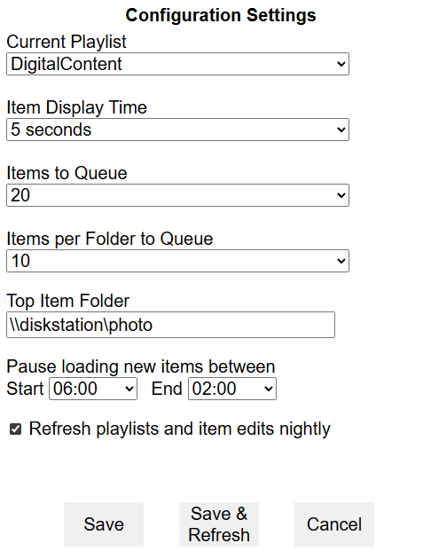

**Figure 14. Configuration Settings Screen (iPhone Example)**

| **Setting** | **Description, Directions and Notes** | |
| --- | --- | --- |
| Current Playlist | The currently active playlist on Digital PictureFrame. You can click this dropdown to see all of your available playlists and select a different one to play (once changed and saved, this is effectively the same functionality as selecting **Current Playlist** from the Home screen). For example, you might have created a playlist for a family friend that you want to play whenever that friend visits. If you only have one playlist created, it will be the only option available in the dropdown. | |
| Item Display Time | The minimum amount of time an item is set to be displayed before the next item in queue will replace it. You can click this dropdown to select a different display time. For example, you might want to see photos more rapidly so that you see more over time, or, more slowly so that you can have ample time to reminisce for each.  Note that while photos will appear for exactly the specified **Item Display Time**, videos act a bit differently based on their playlengths:   * If the length of a video is *greater* than the **Item Display Time**, the video will play out completely before advancing to the next item in queue. For example, if the **Item Display Time** is 15 seconds but the currently displayed video is 48 seconds long, the video will completely play for 48 seconds before the next queue item displaces it. * If the length of a video is *less* than the **Item Display Time**, the video will fully play through at least once and then loop until the **Item Display Time** is reached. For example, if the **Item Display Time** is 15 seconds but the currently displayed video is 10 seconds long, the video will play through once and then restart and play for 5 seconds before the next queue item displaces it. | |
| Items to Queue | The number of items to preload into memory. You can click this dropdown to select a different number of items. Generally a higher number is recommended, with the default set to 20 and maximum allowed value of 30, to minimize network traffic (so that the program retrieves content less frequently), but you can certainly set this value lower if network traffic isn’t of concern or memory is of concern.  Not all of a playlist’s photos and videos will be loaded into memory for performance reasons; a very large playlist of photos and videos can take up a lot of memory. Instead, the items will be randomly selected and placed into queues based on this value. For example, if **Items to Queue** is set to 20 and the playlist has a total of 422 photos and videos, then Digital PictureFrame will create 22 distinct queues (21 queues each containing 20 items and one final queue with the remaining 2 items). | |
| Items per Folder to Queue | The number of items to randomly pick from a folder, which will be grouped together in the queue and sequentially displayed before items from another folder are shown. You can click this dropdown to select a different number of items for each folder. For example, you might want to see only one item from each playlist folder at a time, so that you truly have a single random item displayed each time. Or, you might want to see 5 items from each folder at a time, so that you can reminisce about the folder context before moving to the next folder, such as 5 images from Croatia, 5 images from your child’s 5th birthday party, 5 images from the 2024 work holiday party, and so on. The **Items per Folder to Queue** effectively sets a kind of subqueue within the current queue.  NOTE: The selected value of the **Items to Queue** must be greater than or equal to the **Items per Folder to Queue** value. For example, it would not make sense to have an **Items to Queue** value 5 and an **Items per Folder to Queue** value of 10. The program will prevent selection of such inappropriate values. | |
| Top Item Folder | The usual starting point for all photos and videos in your folder structure (top of the file directory). Only photos and videos within this folder and its subfolders can have comments and be marked sensitive (so that sensitive items can be hidden from a playlist when desired). Although when creating playlists you are able to select multiple drive and network locations, it is not possible to add comment and sensitive markings to the content in these other locations. See **Info - Edit** for details on how to update comments and mark items as sensitive. | |
| Pause loading new items between Start/End | Prevents the program from loading new queues of photos and videos between the selected **Start** and **End** times. Note that times are represented in 24 hours, for example, the ‘22:30’ option is equivalent to 10:30 pm given your PC’s designated time zone. This setting enables you to effectively and automatically pause new playlist queue loading during a time period when no one is usually around to see it, such as sleep times; there is no point in showing new content if no one is around to see it. When the **Start** time is reached, the current playlist queue will continue to play until the **End** time is reached, at which point the next queue in the playlist will be loaded.  NOTE: If your monitor or television has a sleep option, it might make sense to have it enabled for the same timeframe as the **Pause loading new items between Start/End** setting. That way, not only do you pause playing queues, your monitor/television simply turns off and you won’t see the same queue’s content over and over again during this timeframe. | |
| Refresh playlists and item edits nightly | Selecting this checkbox ensures that all updates to playlist and item edits, such as **Comments** and **Sensitive Item** markings, will automatically be refreshed each night at midnight, 00:00hrs .For example, if you use **Info - Edit** to add a new comment to a photo, that new comment will be available via **Info - View**the next day. See **Info - Edit** for details on how to update comments and mark items as sensitive. | |
| Save | Saves all changes made to the settings in this screen and returns you to the More Options screen.  NOTE: When changes are saved, the Current Playlist will be reloaded in order for the changes to take effect immediately. | |
| Save & Refresh | Saves all changes made to the settings in this screen, immediately reloads the current playlist (in order for the changes to take effect immediately), performs a refresh so that all updates to playlist and item edits will take effect (as if the **Refresh playlists and item edits nightly** function has been performed), and returns you to the More Options screen. | |
| Cancel | Does *not* save any changes made to the settings in this screen and returns you to the More Options screen. | |

#### 

#### General Digital PictureFrame Display Info

While Digital PictureFrame is running, there is view-only information you might see on the monitor/television.

| **Feature** | **Description, Directions and Notes** | |
| --- | --- | --- |
| Countdown - Number of Items Remaining | Dynamic graphic image that appears in the bottom left of the display screen to indicate the number of items remaining in the playlist’s current queue.  The number of the currently displayed item appears in the middle of a circular progress bar. For example, in the countdown image on the far left, the currently displayed item is number 19 within the current queue and there are 18 more items to display before a new queue begins. This number will always be equal to or less than the **Items to Queue** setting. | |
| Countdown - Remaining Display Time | Dynamic graphic image that appears in the bottom left of the display screen to indicate the remaining time for the currently displayed item. The time remaining for the currently displayed item appears as a gradually disappearing circle progress indicator (surrounding the **Countdown - Number of Items Remaining** value). This time is based on the **Item Display Time** setting.  If the item is a *photo*, then once the circle is completely gone, the next item will replace it. For example, in the countdown image on the far left a photo has already been displayed for just under ¾ of its set display time and has a little more than ¼ of its set display time left before it will be replaced with a new item.  If the item is a *video*, the circle might repeat depending on the video’s length:   * If the length of a video is *greater* than the **Item Display Time**, the video will play out completely before advancing to the next item in queue. For example, if the **Item Display Time** is 15 seconds but the currently displayed video is 48 seconds long, the video will completely play for 48 seconds before the next queue item displaces it. In this case, the circle progress indicator will appear again and again as needed until the video completes playing. * If the length of a video is *less* than the **Item Display Time**, the video will fully play through at least once and then loop until the **Item Display Time** is reached. For example, if the **Item Display Time** is 15 seconds but the currently displayed video is 10 seconds long, the video will play through once and then restart and play for 5 more seconds before the next queue item displaces it. In this case the circle progress indicator behaves the same as for a displayed photo. | |

#### Keyboard Hotkeys

When using the Windows Digital PictureFrame application, the computer keyboard can be used to control certain features of the application.

| **Hotkey** | **Resulting Action** |
| --- | --- |
| p | play/pause |
| n | go to next item |
| b | go to previous item |
| l | view displayed item’s comments and file path |
| d | display general information about Digital PictureFrame and its current playlist |
| q | display QR code |
| r | rotate item |
| e | mark item for delete |

## SYSTEM REQUIREMENTS

To run the application, you will need the following equipment and specifications.

### Host Computer for the Application

| **Computer**  **Attribute/Peripheral** | **Requirement** |
| --- | --- |
| Operating System | Windows 11 (Windows 10 should work as well, just has not been tested recently) |
| RAM | Minimum 16 Gb - more is always better |
| Hard Drive | Minimum 512 Gb - needs to be large enough to hold all your media if you are accessing locally and not remotely (e.g., not accessing content stored on the internet or Cloud) |
| CPU | Any modern CPU that supports Windows 11 |
| Video | HDMI to connect to monitor or television |
| Keyboard and mouse/input device | * For installation, configuration, and controlling the application’s advanced functionality, or if you do not want to rely on the web browser application for basic interaction * Consider using a bluetooth keyboard and mouse in cast that helps to more easily conceal the computer and these peripherals |

If you have an existing computer with the above specifications, you can absolutely use it. If you would like to have a separate computer just for storing your digital content and running this application, some for affordable example computer configurations from Amazon (as of July 2025) are:

* <https://www.amazon.com/Blackview-MP60-Desktop-Computer-Business/dp/B0C2Q88TZL?ref_=ast_sto_dp&th=1>
* <https://www.amazon.com/Blackview-MP80-Desktop-Computers-Windows/dp/B0CKSGFPKG?ref_=ast_sto_dp&th=1>

### Other Equipment, Applications, & Specs

| **Monitor or Television** | * Any size, for example a 55 inch or larger TV used as a permanent picture frame on your family room wall can be super sweet! * With HDMI to connect to the computer running the application * Optionally with nice speakers if you intend to play videos with sound |
| --- | --- |
| **Digital Content File Types & Size** | Only the following file types are currently supported   * Photos: .jpg, .gif, .png * Videos: .mp4   NOTE: Due to constraints in Base64 conversions, the maximum supported file size for an individual video or photo is 384MB.  NOTE: .gif and .png files cannot have comments or be marked as sensitive; only .jpg and .mp4 file types can have and display comments or be hidden when marked as sensitive. See **Info - Edit** for more details. |
| **Small Screen Device (optional, but very highly recommended)** | Optionally, you can use a small screen device (iPhone, Samsung Galaxy, iPad, etc.) and its browser to control and access key functions and settings for the application, rather than having to access the full application on the computer. This is very highly recommended and generally much more convenient for interacting with Digital PictureFrame, especially if you want to control the display of content with functions such as **Next**, **Previous**, **Pause**, **Volume**, and so on. |

### 

## INSTALLATION & INITIAL CONFIGURATION

### Before Beginning the Installation

Installing and configuring Digital PictureFrame will go more quickly and easily if you have the following before you begin.

* Ensure that you have met all the System Requirements, particularly that the **monitor/television** is set up and connected to an appropriate host computer where the Digital PictureFrame program is to be installed. This will allow you to immediately test and experience the application once installation is complete.
* Ensure that you have identified the **starting folder/directory for your digital content**, as it is required during configuration. It is perfectly fine to have this just be a single folder that contains a couple of photos and videos; the folder structure does not have to be completely set up before installation, you just need a few items to test with. Please do read the Playlists: Tips for Organizing and Naming Folders section before fleshing out your content folder structure, as it may help make playlist creation easier - again, you can tailor the folder structure later at your convenience, so long as you know what the top level of the folder directory will be.

### Step-by-Step Installation Instructions

Digital PictureFrame installs as a standard Windows application.

#### Required Steps

1. Double click, or right click to select ‘Open’, to run the **digitalpictureframe Setup 7.3.0.exe** file (note that the version numbers after “Setup” in the file name may be different/a later version).
   * You will see a Setup progress indicator showing the installation activities

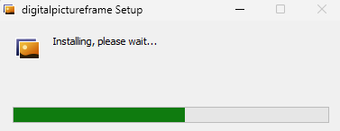

**Figure 15. Installation and Setup Progress Indicator**

* + Once installation is complete, which usually takes less than a minute,
    - the progress indicator disappears
    - all necessary components are installed in location: \Users\<username>\AppData\Local\Programs\digitalpictureframe
    - an uninstaller for the application is added to the Windows ‘add or remove programs’ section
    - a shortcut icon entitled **digitalpictureframe** is added to the desktop for accessing the application

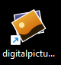

**Figure 16. digitalpictureframe Shortcut Desktop Icon**

1. Double click or right click to select ‘Open’ on the **digitalpictureframe** desktop icon to launch the application.
   * A Digital PictureFrame window will appear with three tabs: **Configuration Settings**, **Playlists**, and **Notifications**.

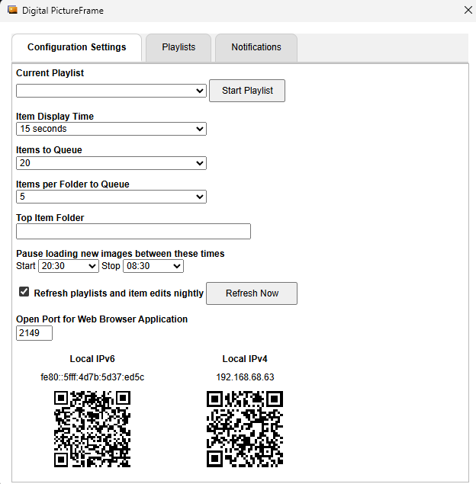

**Figure 17. Initial Digital PictureFrame Screen**

You can safely ignore the Configuration Settings that have default values. However, the application does require a starting point/directory for the primary photos and videos you want the Digital PictureFrame to access. Although when creating playlists you will be able to select multiple drive and network locations, this starting location is important because it sets the default location. Further, all content contained in this top level folder and its subfolders will be able to have comments and sensitive markings.

1. Click the **Top Item Folder** field within the **Configuration Settings** tab.
   * A ‘Select Folder’ window will appear.

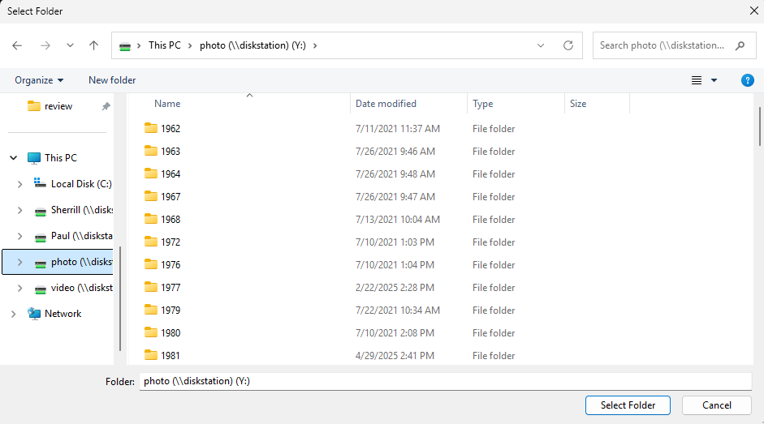

**Figure 18. Example Select Folder Window**

1. Navigate to and select the starting folder/directory for your digital content and then click the **Select Folder** button.
   * For example, in the example screenshot Figure 18 above, the starting directory ‘photo (\\diskstation)’ has been selected, but because it is mapped to the Y drive, when the **Select Folder** button is clicked, ‘Y:\’ is what will be displayed in the **Top Item Folder** field as shown in screenshot Figure 19 below.

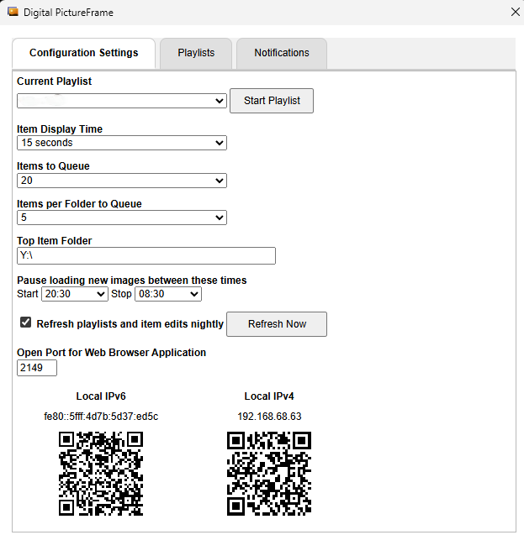

**Figure 19. Example Selected Top Item Folder**

The application requires an open port for web browser (mobile) application access. A default value is provided which should work very well, but if it needs to be changed, now is the time to do so.

1. Review the default value of the **Open Port for Web Browser Application** field and change only if necessary.
   * The default Open Port value ‘2149’ is usually available and not often used by any other application, so it is not recommended to change this value unless you know it is already in use.
   * The Open Port controls the generation of the two Local IP addresses and QR codes. These are used to access Digital PictureFrame from a web browser, such as on your mobile device.
   * NOTE: The Open Port field is only accessible from the client Windows application. It is not available within the web browser application to safeguard against accidental changes. So you will need to use the Windows client application if you ever need to adjust it.

The application requires the existence of at least one playlist in order to play your digital content (so that it knows what to display). A playlist consists of a name, a directory or directories of all the images and videos you wish it to display, and optionally keywords to filter the directory content. You can create multiple playlists, but again at least one must be created at this time.

1. Click on the **Playlists** tab.
   * You will see an empty Playlists list and a right hand panel that has title ‘Edit Playlist’ (though note that because there is no selected existing playlist, there is nothing to be edited yet).

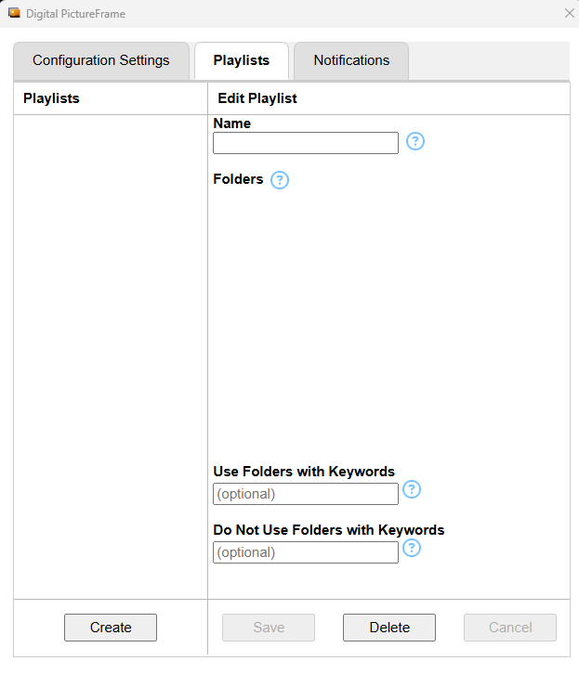

**Figure 20. Playlists Tab when No Playlists Exist**

1. Click the **Create** button in the bottom left of the tab.
   * The right hand panel title will change to **Create Playlist** with most buttons disabled/greyed out and the cursor appearing in the **Name** field.
   * Conversely, because there are no existing playlists, you also can simply start editing the right hand panel even though it had **Edit Playlist** in its title, starting at instruction 8 below.

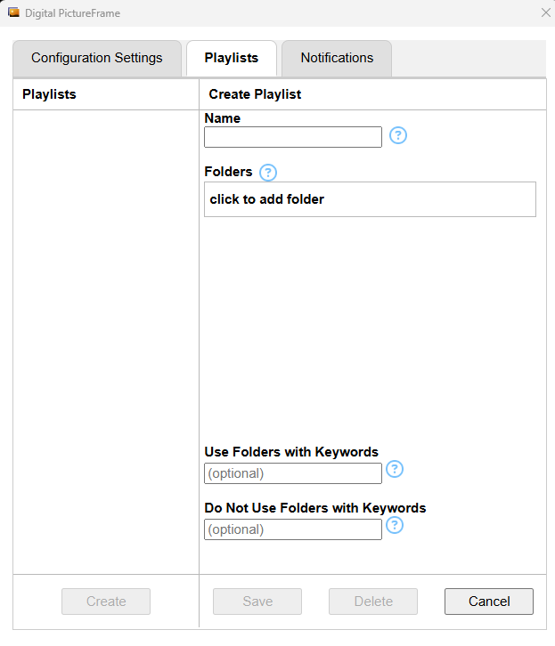

**Figure 21. Create Playlist**

1. In the **Name** field enter a title for this first playlist.
   * The title must be unique and cannot contain any spaces, dashes, or other special characters.
   * The first playlist you create will be the default or current playlist. In the future you can add other playlists as well as change between which is currently being played or selected.
   * For example, a possible playlist **Name** is ‘allcontent’, as a very simple playlist can be for all your current photos and videos.
   * Note that even if you use capital letters, the value entered will be saved in all lower case.
2. Click in the **Folders** table on the **click to add folder** text.
   * The ‘Select Folder’ window opens.
3. Navigate to the first folder you want to include within the playlist, select it, and click the **Select Folder** button.
   * You must select at least one specific folder to include in the playlist. The photos and videos contained in the selected folder(s) and all its subfolders will be included in the playlist content, unless you filter using the keywords fields.
     + If you want to filter in or out specific folder names based on matching keywords, you can optionally enter values in either of the two keywords fields (please see the web browser application Create Playlist description for more details on these two fields).
   * A very good initial playlist is to simply select the same folder as the **Top Item Folder**, which will play all content in the starting folder/directory and its subfolders. For example, in the screenshot below, the starting directory ‘photo (\\diskstation)’ has been selected, but because it is mapped to the Y drive, ‘Y:\’ is what will be displayed in the table.
   * The **Save** button becomes available/enabled/grey once a folder has been selected.
   * If you want to add other specific folders at this time, repeat steps 9-10.
   * If a wrong folder was added and needs to be removed, click the trash bin icon within the folder row.

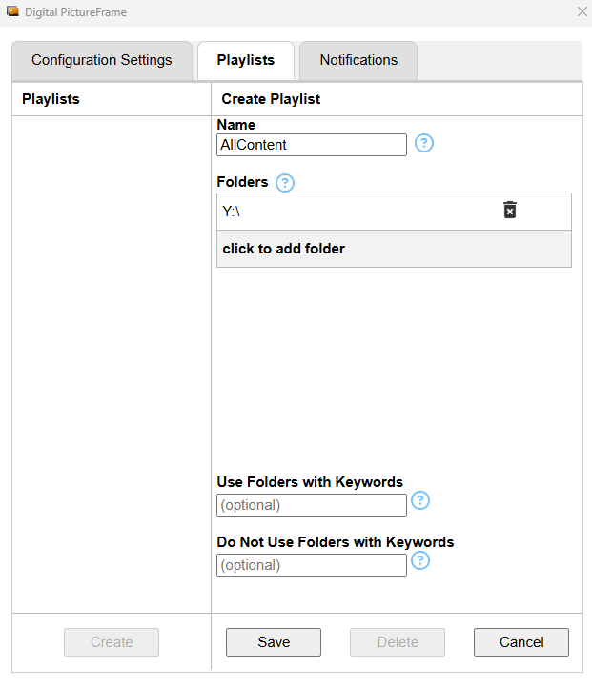

**Figure 22. Example Playlist Name ‘AllContent’ and Selected Folder**

1. Click the **Save** button.
   * Depending on how many photo and video files are in the selected folder(s), you may see a ‘Building Index’ progress indicator, which will disappear a minute or so once the process completes.
   * Once the playlist is successfully created, you will see the playlist name all in lower case in the **Playlists** list.
     + The playlist name within the list will have a little blue star at the end, indicating it is also now the **Current Playlist**
     + It will be selected by default within the list, with the right hand panel title now showing ‘Edit Playlist’ as you can make additional changes to it and save as needed.

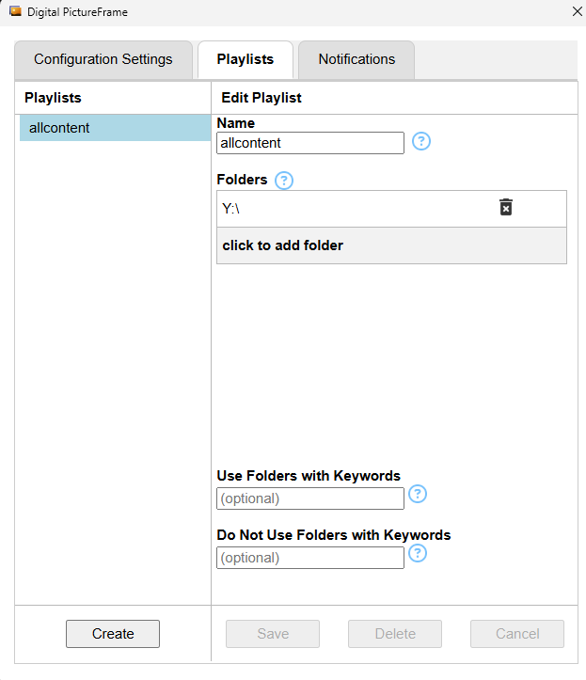

**Figure 23. Example Playlist Successfully Created**

The application requires a quick restart at this point for validation.

1. Close the Digital PictureFrame application by clicking on the ‘X’ in the upper right window corner.
2. Double click or right click to select ‘Open’ on the **digitalpictureframe** desktop icon to relaunch the application.
3. Use one of the two IP addresses to access the web browser application.
   * The **Configuration Settings** tab has two IP addresses with corresponding QR codes available for accessing the web browser application. IPv6 is the newest internet protocol version, IPv4 is the older one. Go to one of these IP addresses from a web browser (e.g., use your device camera to access one of these QR codes) and you will be able to control the Digital PictureFrame while the current playlist is running via the web browser application.
4. Click the **Start Playlist** button to run the **Current Playlist**.
   * This is what installation has been all about and how you actually get to enjoy your digital content!
   * If the Digital PictureFrame takes over your current computer monitor, you can:
     + Use **ALT+TAB** keys to open the application window or other windows
     + Go to one of the IP addresses from a web browser as noted above to control the Digital PictureFrame while the current playlist is running
     + Press the **ESC** key to end running the playlist.

#### Optional/Other Steps

You should be all set and good to go, with Digital PictureFrame running! Try it out, using the web browser application or the Windows client application to see what refinements you might want to make.

1. Optionally, within the Windows application **Configuration Settings** tab, you can adjust the following at any time in the future. These settings are all available within the web browser application, which is highly recommended for on-going usage in lieu of the Windows client application, simply because it is usually more accessible and provides more control over the displayed content.
   * **Current Playlist** - The currently active playlist on Digital PictureFrame. If there is only one playlist, it will be the only option available and selected by default.
   * **Start Playlist** button - When selected, the Digital PictureFrame will load and run the playlist that is shown in the **Current Playlist** dropdown.
   * **Item Display Time** - The minimum amount of time an item is set to be displayed before the next item in queue will replace it. See the web browser application Item Display Time description for more details.
   * **Items to Queue** - The number of items to preload into memory. See the web browser application Items to Queue description for more details.
   * **Items per Folder to Queue** - The number of items to randomly pick from a folder, which will be grouped together in the queue and sequentially displayed before items from another folder are shown. See the web browser application Items per Folder to Queue description for more details.
   * **Pause loading new images between these times** - Prevents the program from loading new queues of photos and videos between the selected **Start** and **End** times. See the web browser application Pause loading new images description for more details.
   * **Refresh playlists and item edits nightly** - Selecting this checkbox ensures that all updates to playlist and item edits, such as changes to folder names and **Comments** and **Sensitive Item** markings, will automatically be refreshed each night. See the web browser application Refresh playlists and item edits nightly description for more details.
   * **Refresh Now** button - Performs a refresh immediately so that all updates to playlist, folder, and item edits will take effect (as if the **Refresh playlists and item edits nightly** function has been performed). See the web browser application Save & Refresh description for more details.
   * **Local IPv6 and IPv4** - Two IP addresses with corresponding QR codes for accessing the web browser application, which is highly recommended for on-going usage and control. IPv6 is the newest internet protocol version, IPv4 is the older one. Go to one of these IP addresses from a web browser (e.g., use your device camera to access one of these QR codes) and you will be able to control the Digital PictureFrame while the current playlist is running via the web browser application.
2. Optionally, within the **Playlists** tab, create additional playlists and manage existing ones. See the playlists from web browser application screen for more details, especially the Create playlist instructions for how to use the **Keywords** fields which have not been covered in these steps. Also, please do read the Playlists: Tips for Organizing and Naming Folders section, as it may help make playlist creation easier.
3. Optionally, view the **Notifications** tab at any time to see lists of items marked for deletion and general warnings, and to clear these lists. See notifications from web browser application for more details.

## SUPPORT

### Playlists: Tips for Organizing and Naming Folders

How you organize your photos and videos in a folder hierarchy and how you name the folders can provide you with great power when creating playlists. It also can help provide valuable context when viewing item info and a displayed item file path, especially when trying to remember where a photo or video was taken.

Playlists identify what digital content to display based on what folders you specify and any keywords you provide:

| **Identification Method** | **How it Works** |
| --- | --- |
| **Playlist Folders** | When creating a playlist you must select one or more specific folders to include so that the playlist will know where to retrieve photos and videos. All of the digital content from that folder and all its subfolders will be included in the playlist unless you filter further by providing keywords.  Note that it is possible to:   * select the exact same playlist folder more than once, such as both ‘DigitalContent > 2025 > vacation > Croatia’ and ‘DigitalContent > 2025 > vacation > Croatia’ * specify folders whose paths overlap, such as both ‘DigitalContent > 2025 > vacation’ and ‘DigitalContent > 2025 > vacation > Croatia’   Doing either of the above causes that folder’s (and its subfolders) digital content to be displayed multiple times when playing the playlist. For example, if you select the folder ‘DigitalContent > 2025 > vacation > Croatia’ three times, then all of its photos and videos randomly will be displayed three times in the course of the playlist playing. Or, if you select both ‘DigitalContent > 2025 > vacation’ and ‘DigitalContent > 2025 > vacation > Croatia’, all of the photos and videos from the ‘vacation’ folder, the ‘Croatia’ folder, and the Croatia subfolders randomly will be displayed twice when the playlist plays. So if you would like to see certain photos and videos more frequently than others in the playlist, you can either include the relevant folder more than once or select appropriate overlapping paths. |
| **Use Folders with Keywords** | Optionally specifying a partial or full word(s) within the **Use Folders with Keywords** field effectively filters and focuses on matching folders within the **Playlist Folders** list. When one or more keywords are provided the playlist will search the specified folders and their subfolders to identify folder names containing the keywords. Only digital content from the matching folders will be included in the playlist. For example, if you select a folder at the top of the hierarchy, say ‘DigitalContent’, and also enter ‘vacat’ within this field, the playlist will identify all folders within ‘DigitalContent’ that have titles including that term, such as ‘Italy Vacation’ or ‘Vacation Home’. Once identified, only the photos and videos in those matching folders will be included in the playlist.   * Spaces and special characters are not supported in this field. For folders that you might use in a keyword search, consider ensuring their names do not include special characters and/or that names with multiple words do not include spaces. * Separate multiple keywords with a comma, for example, ‘vacation,holiday’. * Multiple keywords are not mutually exclusive and act like an ‘or’; if you enter two keywords, folders matching either keyword will be included. * The field is case insensitive; entering a keyword with upper or lower case doesn’t matter, because the folder name case doesn’t have to match the keyword case. |
| **Do Not Use Folders with Keywords** | Optionally specifying a partial or full word(s) within the **Do Not Use Folders with Keywords** field effectively filters out matching folders within the **Playlist Folders** list. When one or more keywords are provided the playlist will search the specified folders and their subfolders to identify folder names containing the keywords. Digital content from the matching folders will be *excluded* from the playlist. For example, if you select a folder at the top of the hierarchy, say ‘DigitalContent’, and also enter ‘georg’ within this field, the playlist will identify all folders within ‘DigitalContent’ that have titles including that term, such as ‘George Birthday’ or ‘Georgia 1993’, and exclude them from the playlist. So the playlist will exclude photos and videos from the matching folders but include all items within ‘DigitalContent’ and within all other folders in its file path, including any of the matching folder’s child folders so long as their names do not also contain ‘georg’.   * Spaces and special characters are not supported in this field. For folders that you might use in a keyword search, consider ensuring their names do not include special characters and/or that names with multiple words do not include spaces. * Separate multiple keywords with a comma, for example, ‘Georg,Charl’. * Multiple keywords are not mutually exclusive and act like an ‘or’; if you enter two keywords, folders matching either keyword will be excluded. * The field is case insensitive; entering a keyword with upper or lower case doesn’t matter, because the folder name case doesn’t have to match the keyword case. |

So, when naming your folders please consider how you might want to filter for inclusion or exclusion. Maybe you want to create playlists based on events, in which case you would want relevant folders to have “birthday”, “vacation”, “holiday”, “trip”, “school”, “graduation”, etc., within their names. Or, maybe you want a playlist to be about a specific year, years, or timeframe, in which case you would want relevant folders to have years or time periods in their names, such as “1967”, “childhood”, or “college”. Or, maybe you want to create a playlist for specific friends when they visit, in which case any folders with content relating to those friends could include a specific word such as the friends’ last name(s) in the folder name, so that you can use that as a keyword.

**NOTE:** Although folder names can normally have spaces and special characters, the keyword fields do not support spaces and special characters. Therefore to make use of this functionality, please consider if folders should have names without spaces and special characters, for example, ‘NewYork’ (instead of ‘New York’) or ‘ACDC’ (instead of ‘AC/DC’).

**NOTE:** It is possible to accidentally enter keywords in both fields that cancel each other out and create an empty playlist. Ensure that the word(s) within the **Use Folders with Keywords** field and the **Do Not Use Folders with Keywords** field do not result in matching the same folder(s).

When organizing your folder hierarchy, consider which digital items should be pulled in whenever a parent folder is identified for the playlist. For example, you could organize your hierarchy as follows:

ꜜ DigitalContent

ꜜ 2024

bees

Christmas

concert VNV nation

ꜜ family

ꜜ Conner

college SMU

general

law School

Paul And Sherrill

ꜜ friends

Darcie

Rob and Darcie

Roger and Deb

hunting

ice Storm

other Family

ꜜ vacation

boston

florida

new york

work Sherrill

ꜜ 2025

2025 camping

ꜜ 2025 concert

2025 concert ACDC

2025 concert Mumford And Sons

2025 Christmas

ꜜ 2025 family

ꜜ 2025 family Conner

2025 family Conner general

2025 law School

2025 work

2025 family Paul And Sherrill

2025 family work Austin

2025 family work NewYork

ꜜ 2025 friends

2025 friends RobAndDarcie

2025 friends RogerAndDeb

2025 friends RossAndKaren

2025 misc Family

ꜜ 2025 vacation

ꜜ 2025 vacation Croatia

2025 vacation Croatia Dubrovnik

2025 vacation Croatia Hvar

2025 vacation Croatia Korcula

2025 vacation Croatia Memories Yacht

2025 vacation Croatia Plitvice

2025 vacation New York

2025 work Sherrill

Given the above example organization and naming and the way the different playlist content identification methods behave, below are 10 examples of configured playlists and what photos and videos they would display.

1. All content

| **Specific Folders** | **Use Folders with Keywords** | **Do Not Use Folders with Keywords** |
| --- | --- | --- |
| DigitalContent |  |  |
| **Playlist would Display** | | |
| All photos and videos, since this is the very top folder in the hierarchy. | | |

2. All ‘2025’ folder and subfolder content

| **Specific Folders** | **Use Folders with Keywords** | **Do Not Use Folders with Keywords** |
| --- | --- | --- |
| DigitalContent > 2025 |  |  |
| **Playlist would Display** | | |
| All photos and videos within the ‘2025’ folder and its subfolders. For example, content from ‘2025 camping’, ‘2025 concert’, ‘2025 concert ACDC’, ‘2025 concert Mumford And Sons’, ‘2025 Christmas’, etc. | | |

3. All content of folders with names that contain ‘vacat’

| **Specific Folders** | **Use Folders with Keywords** | **Do Not Use Folders with Keywords** |
| --- | --- | --- |
| DigitalContent | vacat |  |
| **Playlist would Display** | | |
| All photos and videos within folders whose names contain ‘vacat’, starting evaluation from ‘DigitalContent’ on down. For example only content from:   * the ‘vacation’ folder within 2024 (but *not* its subfolders) * the folders ‘2025 vacation’, ‘2025 vacation Croatia’, ‘2025 vacation Croatia Dubrovnik’, ‘2025 vacation Croatia Hvar’, ‘2025 vacation Croatia Korcula’, ‘2025 vacation Croatia Memories Yacht’, ‘2025 vacation Croatia Plitvice’, and ‘2025 vacation New York’ | | |

4. All ‘vacation’ folder and subfolder content

| **Specific Folders** | **Use Folders with Keywords** | **Do Not Use Folders with Keywords** |
| --- | --- | --- |
| DigitalContent > 2024 > vacation  DigitalContent > 2025 > 2025 vacation |  |  |
| **Playlist would Display** | | |
| All photos and videos within specified folders and subfolders, including:   * the ‘vacation’ folder within 2024 and its subfolders ‘boston’, ‘florida’, and ‘new york’ * the folders ‘2025 vacation’, ‘2025 vacation Croatia’, ‘2025 vacation Croatia Dubrovnik’, ‘2025 vacation Croatia Hvar’, ‘2025 vacation Croatia Korcula’, ‘2025 vacation Croatia Memories Yacht’, ‘2025 vacation Croatia Plitvice’, and ‘2025 vacation New York’ | | |

5. All content of folders with names that contain ‘croatia’

| **Specific Folders** | **Use Folders with Keywords** | **Do Not Use Folders with Keywords** |
| --- | --- | --- |
| DigitalContent | croatia |  |
| **Playlist would Display** | | |
| All photos and videos within folders whose names contain ‘croatia’, starting evaluation from ‘DigitalContent’ on down. For example, only content from the folders ‘2025 vacation Croatia’, ‘2025 vacation Croatia Dubrovnik’, ‘2025 vacation Croatia Hvar’, ‘2025 vacation Croatia Korcula’, ‘2025 vacation Croatia Memories Yacht’, and ‘2025 vacation Croatia Plitvice’. | | |

6. All content of folders with names that contain ‘vacat’ and *not* ‘croatia’

| **Specific Folders** | **Use Folders with Keywords** | **Do Not Use Folders with Keywords** |
| --- | --- | --- |
| DigitalContent | vacat | croatia |
| **Playlist would Display** | | |
| All photos and videos within folders whose names contain ‘vacat’ and do not contain ‘croatia’, starting evaluation from ‘DigitalContent’ on down. For example, only content from:   * the ‘vacation’ folder within 2024 (but *not* its subfolders) * the folders ‘2025 vacation’ and ‘2025 vacation New York’ | | |

7. All ‘2025 vacation’ folder and subfolder content, all ‘2025 vacation New York’ folder and subfolder content (so content from the ‘2025 vacation New York’ folder effectively appears twice within the playlist)

| **Specific Folders** | **Use Folders with Keywords** | **Do Not Use Folders with Keywords** |
| --- | --- | --- |
| DigitalContent > 2025 > 2025 vacation  DigitalContent > 2025 > 2025 vacation > 2025 vacation New York |  |  |
| **Playlist would Display** | | |
| All photos and videos within the ‘DigitalContent > 2025 > vacation’ folder and its subfolders, AND, all within the ‘2025 vacation New York’ folder. Because ‘2025 vacation New York’ also is part of/overlaps with the ‘DigitalContent > 2025 > 2025 vacation’ path, its photos and videos *will appear twice* within the playlist. For example, all items from the folders:   * ‘2025 vacation’, ‘2025 vacation Croatia’, ‘2025 vacation Croatia Dubrovnik’, ‘2025 vacation Croatia Hvar’, ‘2025 vacation Croatia Korcula’, ‘2025 vacation Croatia Memories Yacht’, ‘2025 vacation Croatia Plitvice’, and ‘2025 vacation New York’ * and again, ‘2025 vacation New York’ | | |

8. All content of folders with names that contain ‘rob’ or ‘darcie’

| **Specific Folders** | **Use Folders with Keywords** | **Do Not Use Folders with Keywords** |
| --- | --- | --- |
| DigitalContent | rob,darcie |  |
| **Playlist would Display** | | |
| All photos and videos within DigitalContent with folder names containing ‘rob’ or ‘darcie’. For example, items from the folders:   * ‘Darcie’ * ‘Rob and Darcie’ * ‘2025 RobAndDarcie’ | | |

9. All content of folders with names that contain ‘robanddarcie’

| **Specific Folders** | **Use Folders with Keywords** | **Do Not Use Folders with Keywords** |
| --- | --- | --- |
| DigitalContent | robanddarcie |  |
| **Playlist would Display** | | |
| All photos and videos within DigitalContent with folder names containing ‘robanddarcie’. For example, just items from the ‘2025 RobAndDarcie’ folder. | | |

10. Empty/broken playlist (do not do this!)

| **Specific Folders** | **Use Folders with Keywords** | **Do Not Use Folders with Keywords** |
| --- | --- | --- |
| DigitalContent | vacat | vacat |
| **Playlist would Display** | | |
| Nothing; if the folders identified from the **Use Folders with Keywords** field are the same folders identified from the **Do Not Use Folders with Keywords** field, they *cancel each other out* and the playlist will be empty. | | |

Finally, how you name your folders impacts not just folder selection and keywords, it also affects the length and readability of how file info is shown in Digital PictureFrame. When you select **Info - View** for a playlist’s displayed item then you will see a file path and name that can provide context for where the photo or video was taken. Given the example organization and naming above, here are some example file names and paths that might appear when **Info - View** is selected for an item:

* \\C:\DigitalContent\2024\vacation\new york\<filename>.jpg
* \\C:\DigitalContent\2025\2025 vacation\2025 vacation NewYork\<filename>.jpg
* \\C:\DigitalContent\2025\2025 vacation\2025 vacation Croatia\2025 vacation Croatia Korcula\<filename>.mp4

The above was just one possible example of how you could organize and name your digital content folders and was not intended to imply one way is better than another. There is nothing wrong with having a single folder containing your photos and videos or only one or two levels of folders, with or without repeating parent folder names. Organize and name your folders based on what makes the most sense and best meets your playlist creation needs! Keep in mind that you can always adjust your folder hierarchy and folder names in the future, especially as you add digital content over time. Just make sure that you consider and review potential impacts to existing playlist configurations if you do add or change existing folder names and locations.

### Trouble Shooting

Following are some potential issues that might be experienced along with information and recommendations for resolution, where practical. If you still experience an issue after trying the recommended actions, please contact Support for further assistance.

| **Problem or Experience** | **Why and What to Try** |
| --- | --- |
| **Previous** function () does not go back to the previous image | This is because the prior item was the last item in the preceding queue, while the currently displayed item is the first item in the current queue. Because the currently displayed item is the first item in the current queue, there is no prior item in memory to go back to because the prior queue is no longer in memory. |
| Image is not displayed across the entire screen | Images and videos are scaled as best as possible to fit the display. This may mean a video or image does not fill the entire display in order to avoid the scaled file being larger than the display. When this happens, the item will be displayed in the middle of the screen and then the areas outside the full display will be an enlarged image of the center of the item.  Originally the areas outside the full display were simply black, but it just didn’t look very nice. Instead, having the enlarged image is better and sometimes highlights some interesting parts of an image! |
| The display appears to flicker when switching to the next photo or video | To improve the playback experience you can try:   1. Reducing the number of icons on the Windows computer desktop that is running Digital PictureFrame program to as few as possible so the flicker is less noticeable 2. Changing the Windows computer desktop background color to solid black so the flicker is less noticeable    * This computer setting is found under ‘Settings -> Personalization -> Background’    * In the **Personalize your Background** dropdown, select “Solid color” (or ensure it is already selected)    * Under **Choose your background color** select the black color 3. Set the Windows computer taskbar to automatically hide to make the flicker less noticeable    * This computer setting is found under ‘Settings -> Personalization -> Taskbar -> Taskbar behaviours’    * Select the **Automatically hide the taskbar** checkbox |
| No access to the web browser application | You can use the client/PC application to see the web browser application IP addresses and QR codes. Double click or right click to select ‘Open’ on the **digitalpictureframe** desktop icon to launch the application. Then on the **Configuration Settings** tab, use either the Local IPv6 or Local IPv4 QR codes (or their IP addresses) to access the web browser application from your device.  NOTE: The web application relies on the current IP address of the Windows computer running Digital PictureFrame. When a computer restarts, most routers automatically assign a new IP address. Consider using the “Address Reservation” feature of your router to set an IP address for Digital PictureFrame’s computer that does not change if the computer or router is rebooted. |
| A photo or video never appears to be displayed | This may be caused by various situations:   * It may be that the **item file size is too large**. Due to constraints in Base64 conversions, the maximum supported file size for videos or images is 384MB. You can check the **Notifications**option General Warnings sectionto see if there is a ‘copyError’ that the item couldn’t be loaded into memory. If there is and the item file path is listed, then it is too large and simply cannot be displayed (it will always be skipped in the queue because it is too large). * It may be that the **playlist where you expect to see the item isn’t identifying the item for inclusion**, or, the **starting folder structure has been modified and/or folders renamed** such that the playlist configuration is no longer correct. Review the configuration of the Playlist that should be showing this item to ensure it should be included. First ensure that the item is in a folder that is either selected for the playlist or is one of the selected folder’s subfolders (in the **Playlist Folders** list). Then, check if a keyword is entered that is excluding its folder, either because its folder name does not contain one of the words in the **Use Folders with Keywords** field, or, its folder name contains one of the words in the **Do Not Use Folders with Keywords** field. |
| A photo or video is displayed more than once for the same playlist | This is likely due to either the playlist configuration, or, the **Pause loading new items between Start/End** setting.   * Review the playlist configuration to see if (a) the same folder is specified more than once, or, (b) if there are two folder paths that overlap. For example, if the folder ‘DigitalContent > 2025 > vacation > Croatia’ was selected three times, then all of its photos and videos will be displayed three times in the course of the playlist playing. Or, if both ‘DigitalContent > 2025 > vacation’ and ‘DigitalContent > 2025 > vacation > Croatia’ are both selected, then all of the photos and videos from the ‘vacation’ folder, the ‘Croatia’ folder, and the Croatia subfolders will be displayed twice when the playlist plays. * Review the **Pause loading new items between Start/End**setting **Start** and **End** times and whether or not the display repeat occurred within the **Start** to **End** timeframe. During the **Start** to **End** timeframe the same playlist queue will repeat because no new queues are being loaded, causing the same set of items to display over and over again. |
| John Travolta is displayed, looking around with a quizzical expression | This is rare but if it happens, Mr. Travolta will eventually disappear, replaced by the next valid item in the queue once the **Item Display Time** limit is reached. It only happens when the item that was queued cannot be found, usually because a folder or item file has been renamed, deleted, or moved. Specifically, the file path to the image or video is no longer valid. If the **Refresh playlists and item edits nightly** option within the Configuration Setting Screen is enabled/selected, file paths and names for playlists are updated each night, fixing this issue. Or, you can fix immediately by selecting the **Save & Refresh**button within the Configuration Setting Screen.  NOTE: Because Digital PictureFrame is not commercially available and only privately used by close friends and family of the creators, this is an homage to the movie ‘Pulp Fiction’ and Mr. Travolta; this image would be replaced if this application were to become publicly available. |
| Display is completely black | For some reason an item cannot be displayed. This sometimes occurs when a file is loaded into memory and the Base64 conversion encounters an error.  This is very rare and the black screen should disappear once the **Item Display Time** limit is reached, at which point the next item in queue will appear. Or, in even rarer events, the application will automatically reset and restart.  Another possibility is that your monitor or television has a sleep option, causing it to be black/appear off. It makes sense to have the television sleep option enabled for the same timeframe as the **Pause loading new items between Start/End** setting. That way not only do you pause playing queues, your monitor/television simply turns off and you won’t see the same queue’s content over and over again during this timeframe. |

### Support & Acknowledgements

If the Trouble Shooting section is not sufficient, you need more detailed support, or if you would like to provide feedback or feature requests, please contact the application creators:

Paul Packebush - [ppackebush@gmail.com](mailto:ppackebush@gmail.com)

Sherrill Packebush - [sherrill.packebush@gmail.com](mailto:sherrill.packebush@gmail.com)

This project uses the following open-source libraries and tools:

* [Electron] (https://www.electronjs.org/) – Build cross-platform desktop apps with JavaScript.
* [Node.js] (https://nodejs.org/) – Runtime environment.
* [ExifTool vendored] (https://www.npmjs.com/package/exiftool-vendored) (vendored) – For reading and writing metadata in image files.
* [Better-SQLite3] (https://github.com/WiseLibs/better-sqlite3) – Fast SQLite3 bindings for Node.js.
* [QR Code JS] (https://github.com/davidshimjs/qrcodejs) - QR code generation
* [FFMPEG] (https://ffmpeg.org/) - Editing video files and adding meta data
* [Express] (https://expressjs.com/) - Web framework for mobile applications